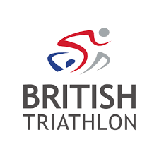
Parental Consent Form
Name Of Club:
Child’s First Name:
Child’s Surname:
Parent / Carer’s Name:
Home Address:

Post Code:
Telephone Number:

Date Of Birth: __ __ / __ __ / __ __ __ __ Age:
Gender: Male ☐ Female ☐
Details of Activity (Dates/Times/Season/Location)

Emergency Contact Information
Emergency Contact Name:
Emergency Contact Number: Mobile:
Alternative Contact Name:
Alternative Contact Number: Mobile:
Child’s Doctor’s Surgery and Contact Number:

Medical Information
Does your child experience any conditions requiring medical treatment and/or medication?
Yes ☐ No ☐
If Yes Please Provide Details:
Does your child have any allergies?
Yes ☐ No ☐
If Yes Please Provide Details:
Please Provide any further information you feel necessary:
- I have received details of the above activity and am aware of the British Triathlon’s child Protection Policy and Procedures.
- I consent to my child taking part in the activities detailed. I acknowledge that the club will be liable in the event of an accident only if they have failed to take reasonable steps in their duty of care for my child during the activity
- I agree to be at the drop-off/pick-up point at the agreed time.
- I confirm to the best of my knowledge that my child does not knowingly suffer from any medical condition other than those detailed above.
- I consent to my child receiving medical treatment which in the opinion of a qualified medical practitioner may be necessary.
Parent/Carer’s Signature
Print Name:
Date:

